# 

# Computer Organization & Assembly Language……

Software downloading screen shoots with documentation

1. Type EMU86 in Google URL



1. List of EMU86 software from different sites are appear.  
   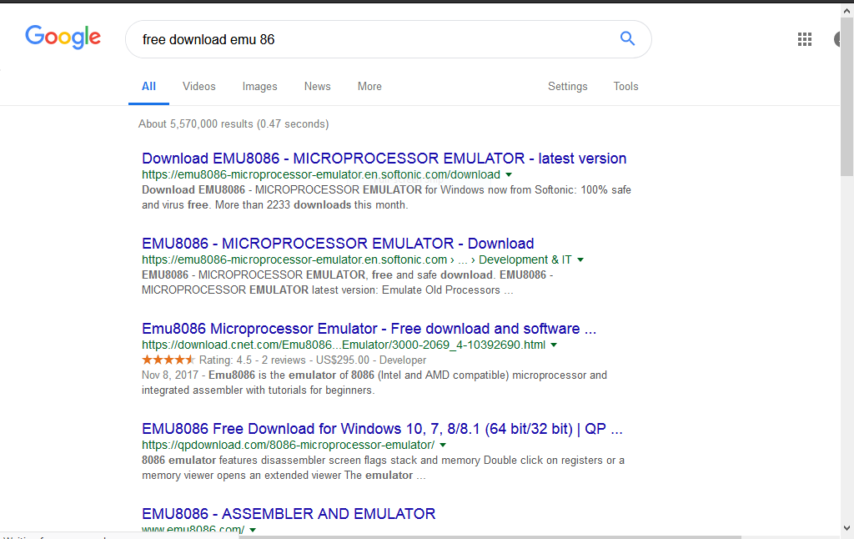
2. Select latest version of EMU86 then a dialogue box will be appeared click on “Save File’’ then click OK.

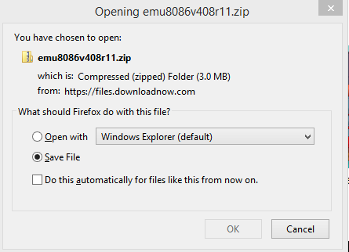

1. Some software are save in zip File.

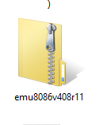

1. First Abstract it before installing

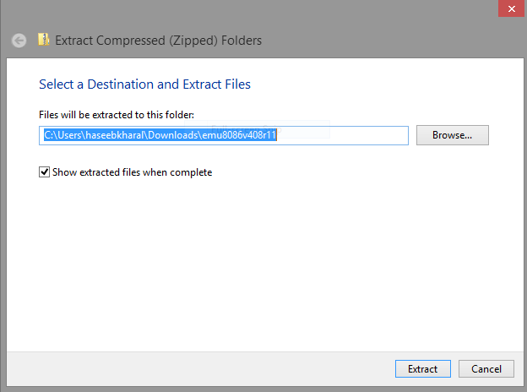

1. Now click on Setup

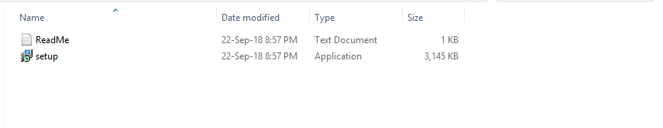

1. A dialogue will be appeared ,click on ‘’RUN”

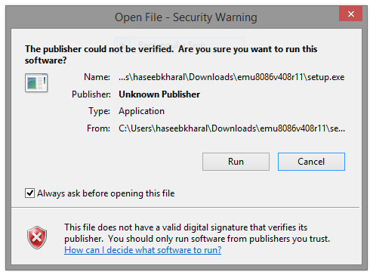

1. Now again an dialogue box will be appeared select “yes” to start installing software in your computer.

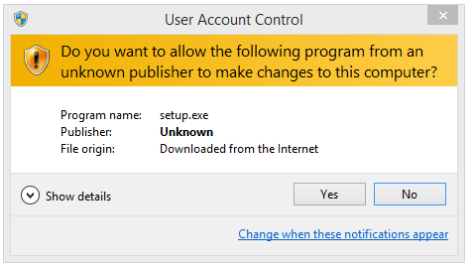  
9. Click on “NEXT”

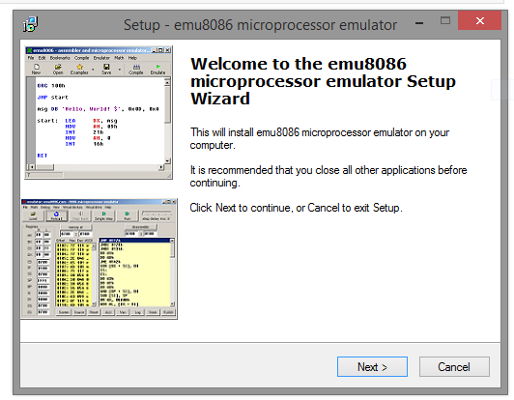

10. Now click on “FINISH”

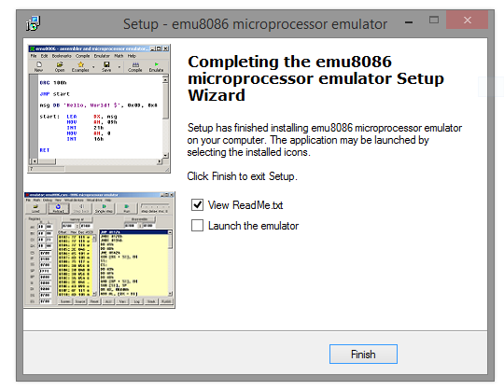

11. A read me text document, notepad will be appeared after finishing software installment

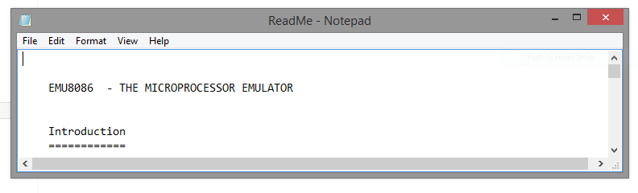

12. logo of EMU 86 WILL BE SHOWN on your pc screen ,Right double click that logo and you will see start menu and click on NEW

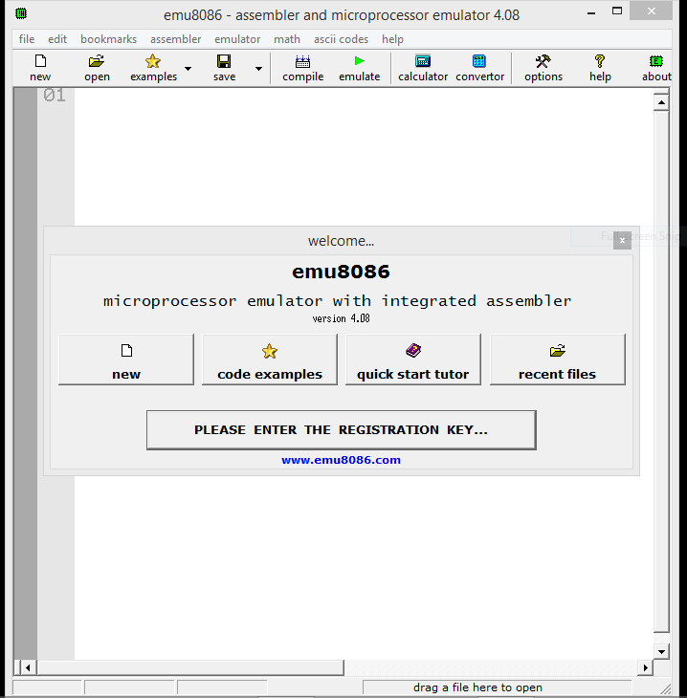

13. Select CDM-Simple and tiny pure machine code then click on “ok”

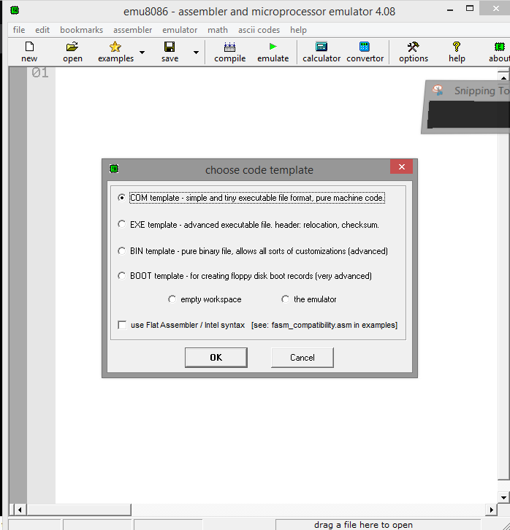

14. Home page of EMU86.

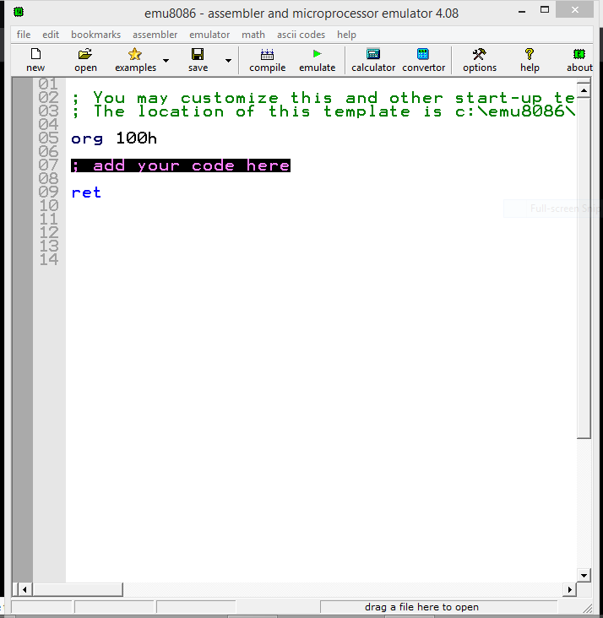

15.click on “cross sign” for EXIT again an dialogue box appeared “do you want to save it” ,select any option .

